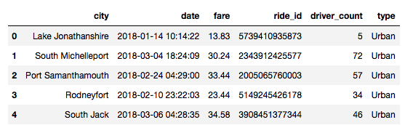

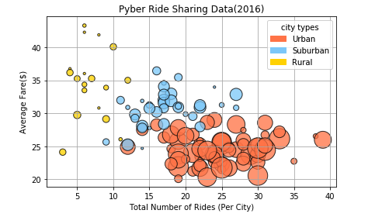

Fares increase in price and decrease in rides taken in smaller rural area. As the number of rides increases in more populated areas in urban areas it brings the average fare lower. Drivers in total earn the largest percentage of fares and give more rides in larger populated areas. There are less drivers in suburban areas than urban giving more rides than their counterparts in the urban areas. Rural and suburban drivers are able to take advantage of their scarcity and charge higher fares and for less rides than their urban drivers.

